Exercise: Architecture and Testing
Submit your solutions in the SoftUni judge system at:
https://alpha.judge.softuni.org/contests/architecture-and-testing-exercise/3298/compete
Working with Remote Data
For the solution of some of the following tasks, you will need to use an up-to-date version of the local REST service, provided in the lesson’s resources archive. You can read the documentation here.

Messenger – Testing
Your task is to write tests for the functionality of the "Messenger" problem from the previous lessons. The solution must be obtained prior to implementing test. This app doesn't need any registration. Every user is able to write a new message.

Testing: load messages
First you need to test if all the messages are loaded and showed on the webpage by clicking the "Refresh" button.

Testing: send message
You need to test also the functionality of the sending a new message. Test if by clicking the "Send" button a request to the database is send with the right parameters.

Book Library – Testing
This task is to write tests for the functionality of the Book Library problem from the previous lessons. The solution must be obtained prior to implementing test. This app doesn't need any registration. Every user is able to read,write, edit and delete the book details.

Testing: load books
First you need to test if all the books are loaded and showed on the webpage by clicking the "Load all books" button.

Testing: add book
The second thing you need to test is the functionality of the adding a new book. Test the validation of the input fields (no empty input fields are allowed by creating a new book). Test if the right request with the correct parameters is send to the back-end. Note there are two forms on the page!

Testing: edit book
The next thing for testing is the edit functionality. When the “Edit” button is clicked, the correct form should be made visible (note there are two forms in the page) and it’s input fields must show the title and author of the selected book. By clicking the "Save" button a PUT request with the right parameters should be sent to the back-end.

Testing: delete book
The last testing is the delete functionality. By clicking the "Delete" button, a confirmation dialog should open. Confirming the dialog should send the correct request to the back-end.

SoftTerest *
This task has automated tests, included in the resources. To run the tests, install dependencies with npm install, then run in two separate terminals the following commands:
npm run start
npm run test
There is no need to submit this task for manual peer-assessment.
You are assigned to implement a Single Web Application (SPA), such that it passes all provided tests. The app keeps users and ideas. Guests should be able to register and login. Users should be able to view all ideas, create ideas, see details about an idea and logout. Users should also be able to delete the ideas they have created.

Navigation Bar
Navigation links should correctly change the current page (view).
- Clicking on the links in the NavBar should display the view behind the link (views are represented as sections in the HTML code).
- Your application may hide/show elements by CSS (display: none) or delete/reattach from and to the DOM all unneeded elements, or just display the views it needs to display.
- The Logged-in user navbar should contain the following elements: Icon (icon.jpg) which is a link to the Home page, [Dashboard], [Create], [Logout].
  - The Icon should be a link that navigates to the currently logged in user’s profile.
- The guest users navbar should contain the following elements: : Icon (icon.jpg) which is a link to the Home page, [Dashboard], [Register] and [Login].

Home Page
The initial page (view) should display the navigation bar ("Home" (icon), "Dashboard", "Register"and "Login") + Home Page + Footer.
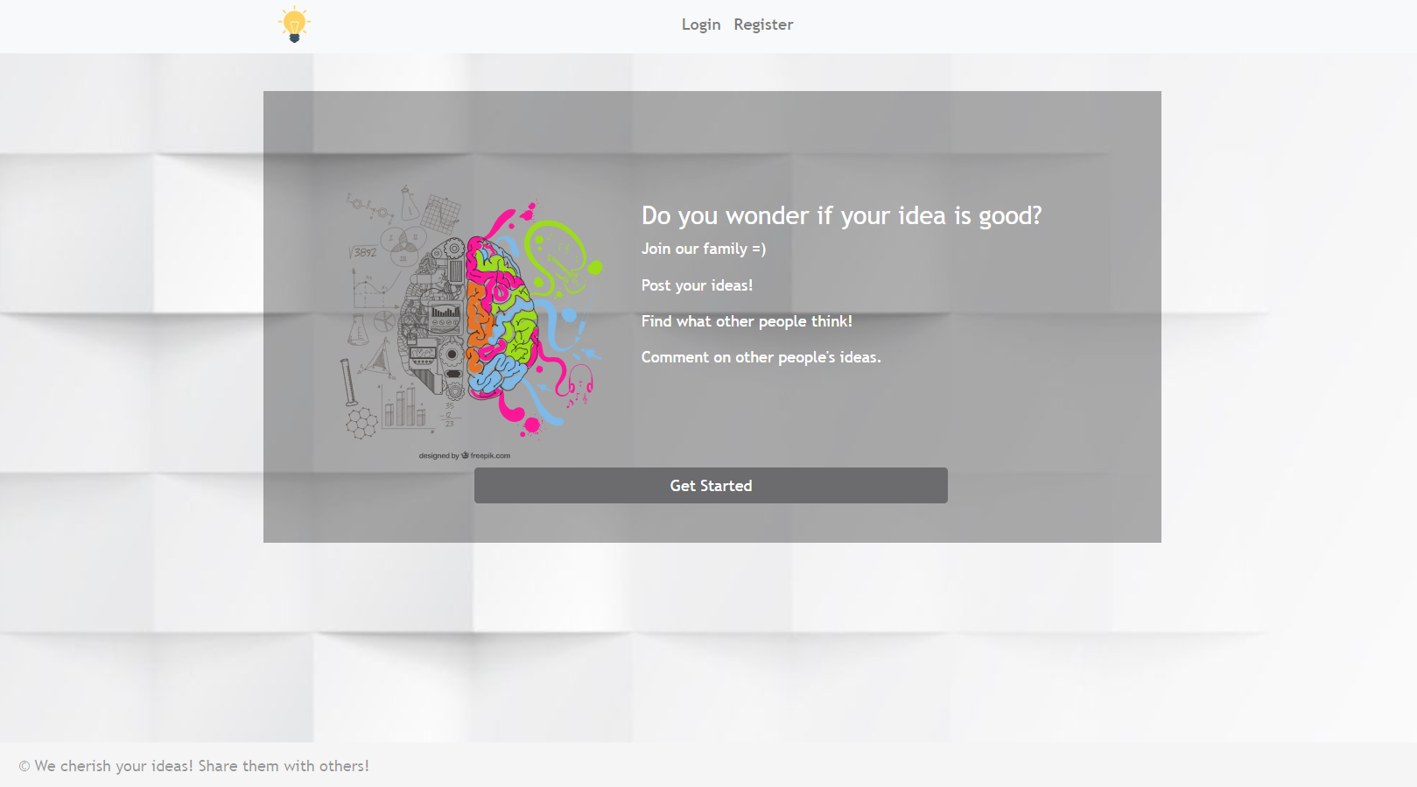

Register User
By given email and password, the app should register a new user in the system.
- The following validations should be made:
  - The email should be at least 3 characters long
  - The password should be at least 3 characters long
  - The repeat password should be equal to the password
- After a successful registration the app should redirect to the home page with the right navbar.
- In case of error (eg. invalid email/password), the user should be able to try to register again.
- Keep the user session data in the browser's local storage.
- POST request - http://localhost:3030/users/register
Register once and create/Like awesome ideas!
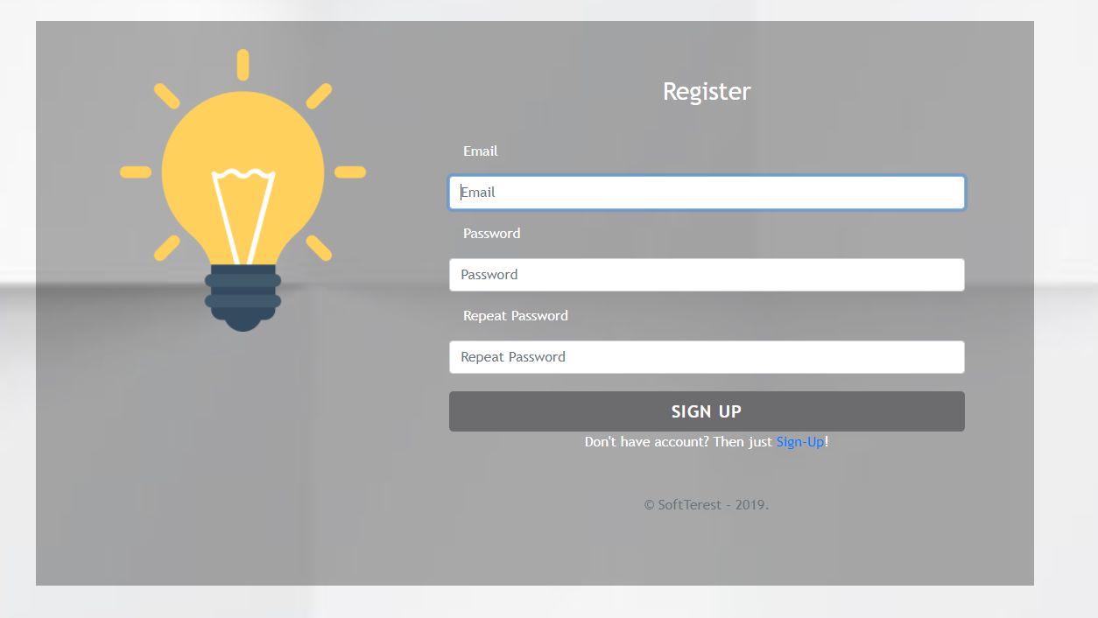

Login User
By given email and password, the app should login an existing user.
- After a successful login and the user home screen should be displayed.
- In case of error, the user should be able to fill in the login form again.
- Keep the user session data in the browser's local storage.
- Clear all input fields after a successful login.
- POST request - http://localhost:3030/users/login
You are one step away from awesome ideas!
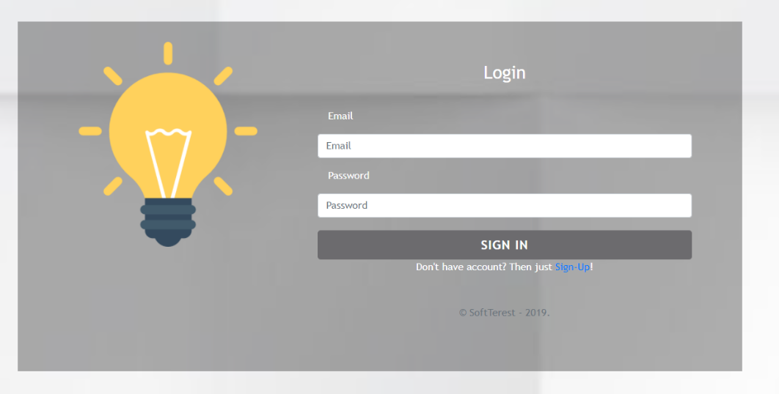

Logout
Successfully logged in users should be able to logout from the app.
- After a successful logot the anonymous screen should be shown
- The "logout" REST service at the back-end must be called at logout
- All local information in the browser (user session data) about the current user should be deleted
- GET request - http://localhost:3030/users/logout

Dashboard
All users should be able to see the Dashboard. They should be able to see all created ideas.
GET request - http://localhost:3030/data/ideas?select=_id%2Ctitle%2Cimg&sortBy=_createdOn%20desc
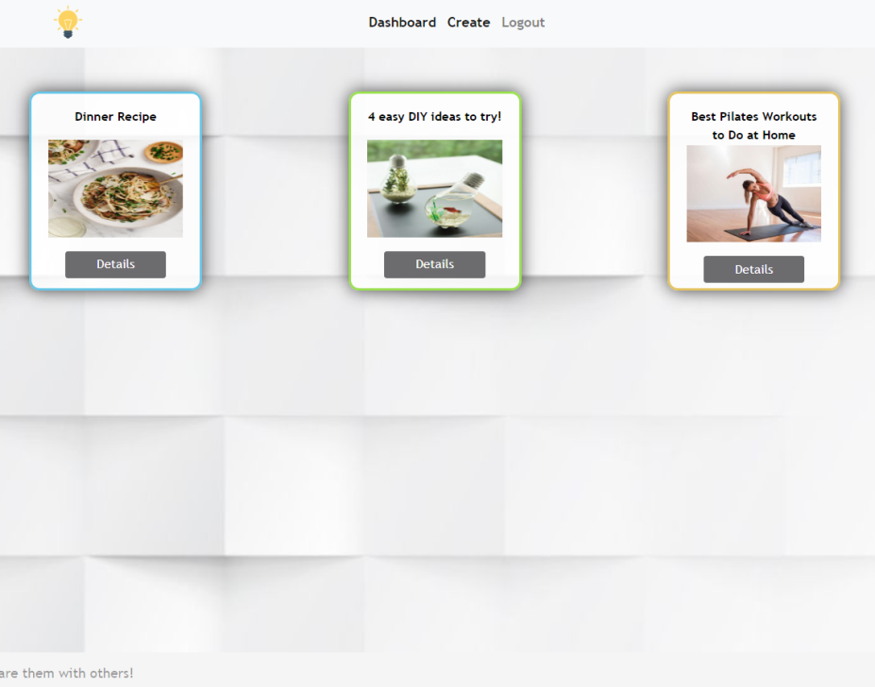
If there are NO such ideas, the following view should be displayed:


Create
Logged-in users should be able to Create ideas.
Clicking the [Create] link in the NavBar should display the Create page.
- The form should contain the following validations:
  - The title should be at least 6 characters long.
  - The description should be at least 10 characters long.
  - The image should be at least 5 characters long.
  - After a successful idea creation the Dashboard should be shown.
- The inputs fields in the form should be cleared.
- POST request - http://localhost:3030/data/ideas
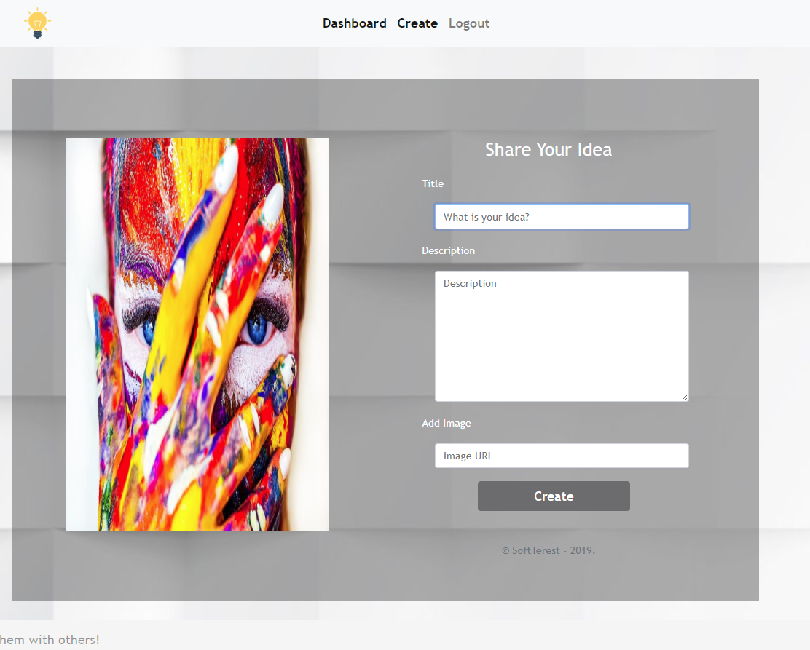

Idea Details
All users should be able to view details about ideas.
Clicking the [Details] link in of a particular idea should display the Idea Details page.
- If the currently logged-in user is the organizer of the idea, [Delete] button should be set to visible.
GET request - http://localhost:3030/data/ideas/:id – for idea details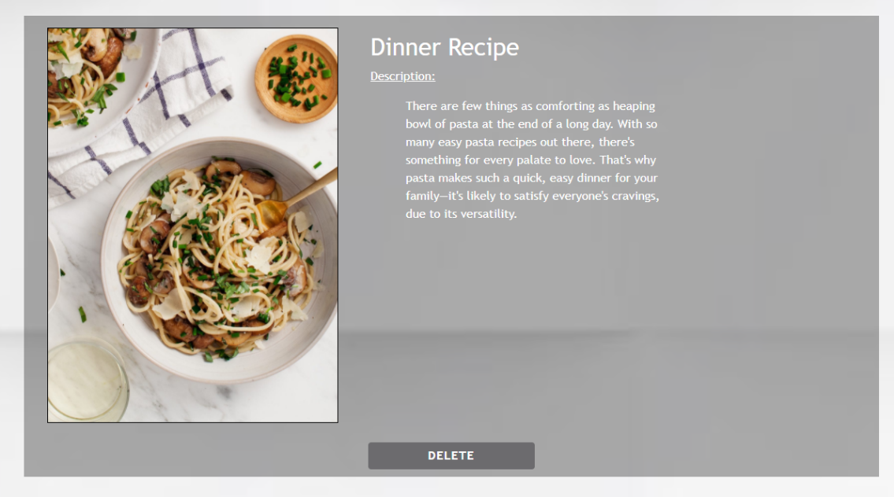

Delete Idea
Logged-in users should be able to delete their ideas.
Clicking the [Delete] link of an idea (on the Idea Details page) should delete the idea.
- After successful idea delete the Dashboard should be shown
- DELETE request - http://localhost:3030/data/ideas/:id

Submitting Your Solution
Place in a ZIP file the content of the given resources including your solution. Exclude the node_modules folder if there is one. Upload the archive to Judge.
